COMSATS UNIVERSITY ISLAMABAD
ATTOCK CAMPUS

DEPARTMENT OF COMPUTER SCIENCE

COURSE | DevOps
INSTRUCTOR | Mr Muhammad Kamran
LAB mid | DevOps LAB MID
STUDENT DETAILS
NAME | REGISTRATION NO.
Mahad Farooq | FA23-BSE-036

1. Local Web Application & Test Suite Verification
The Flask Assignment Submission Portal (app.py) manages student assignment submissions, enforcing validation for registration numbers and submission URLs. Local test execution via pytest verifies application logic prior to pushing code to remote repositories.
Assignment Submission Portal Web Interface:
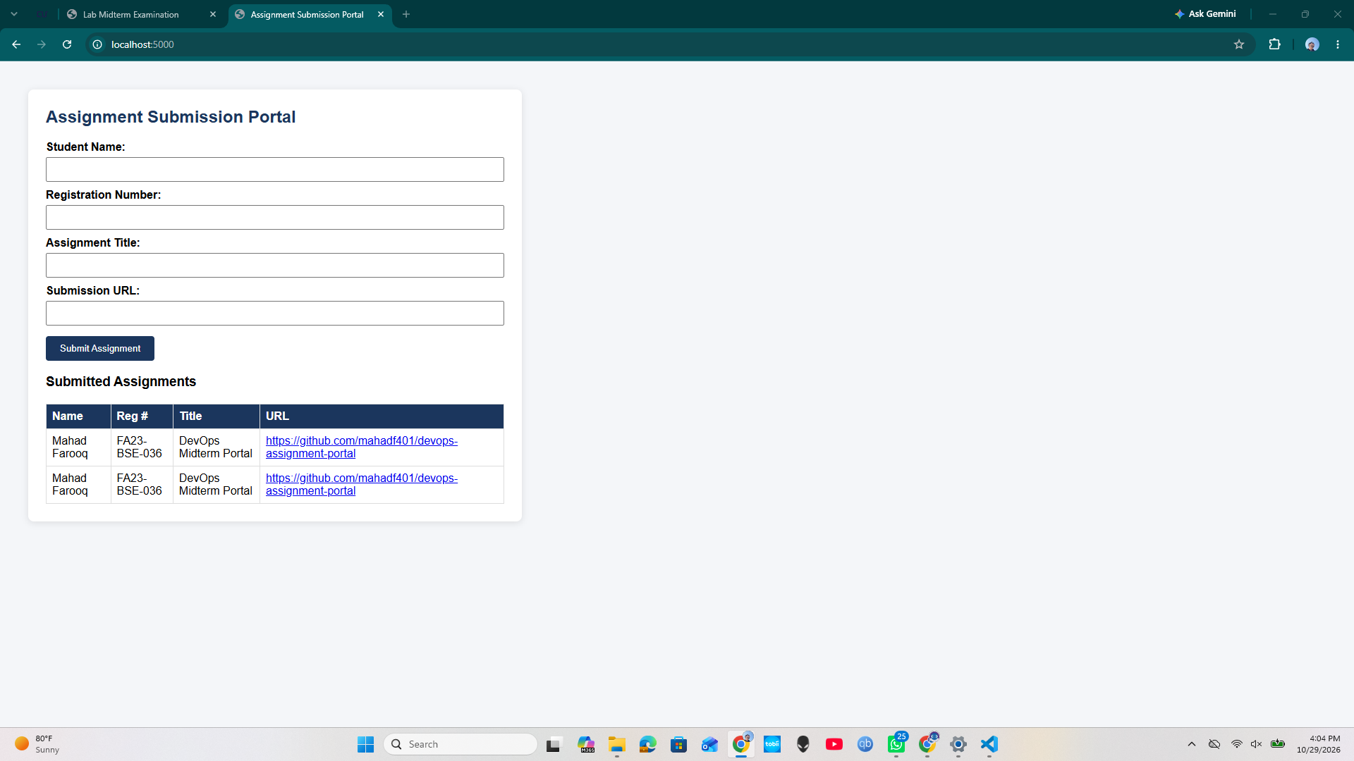

Pytest Execution Output: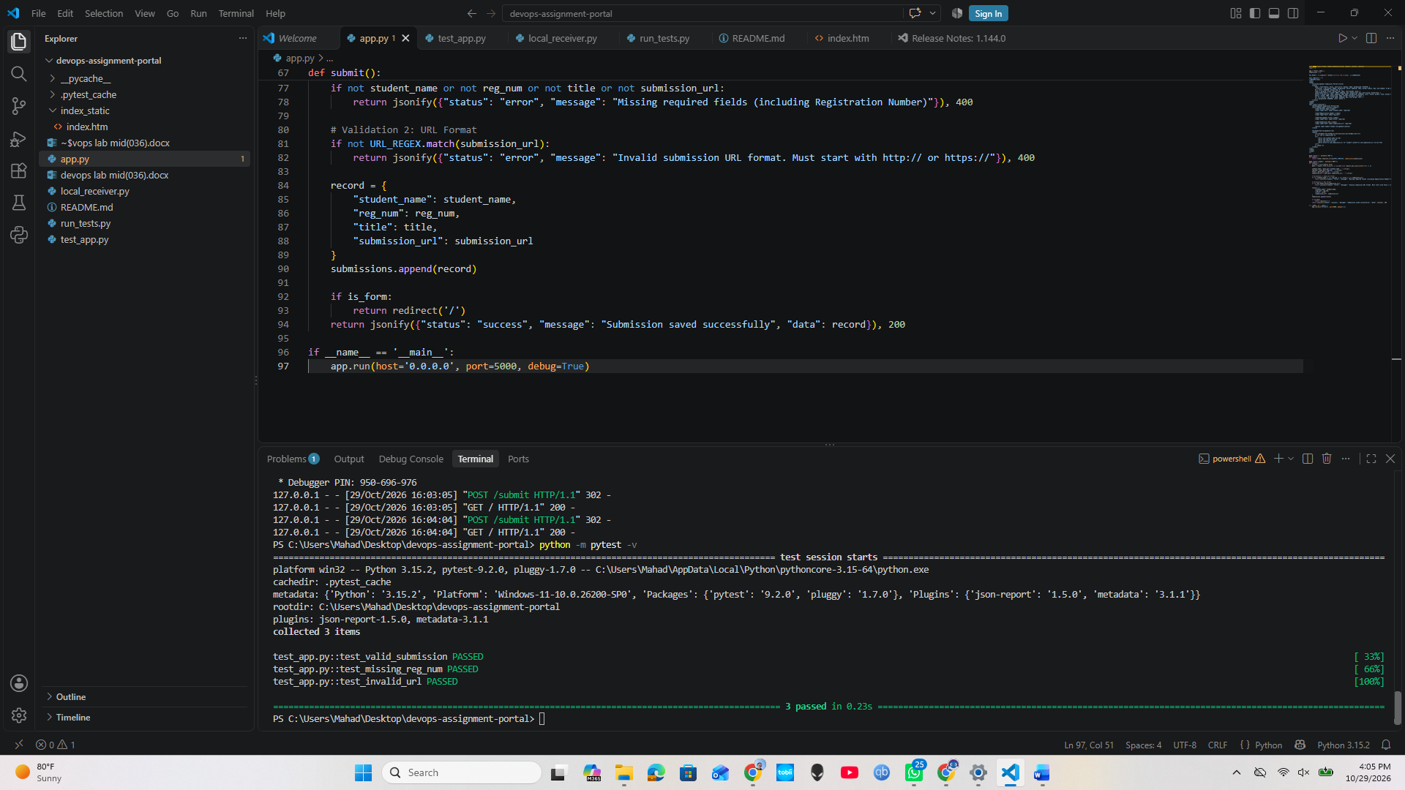

2. Infrastructure Setup & Tunneling Configuration
To allow cloud-hosted GitHub Actions runners to send test results to a local environment without exposing local ports or modifying router settings, an SSH tunnel via localhost.run forwards incoming traffic to local_receiver.py listening on port 5000.
Local Receiver & SSH Tunnel Terminal: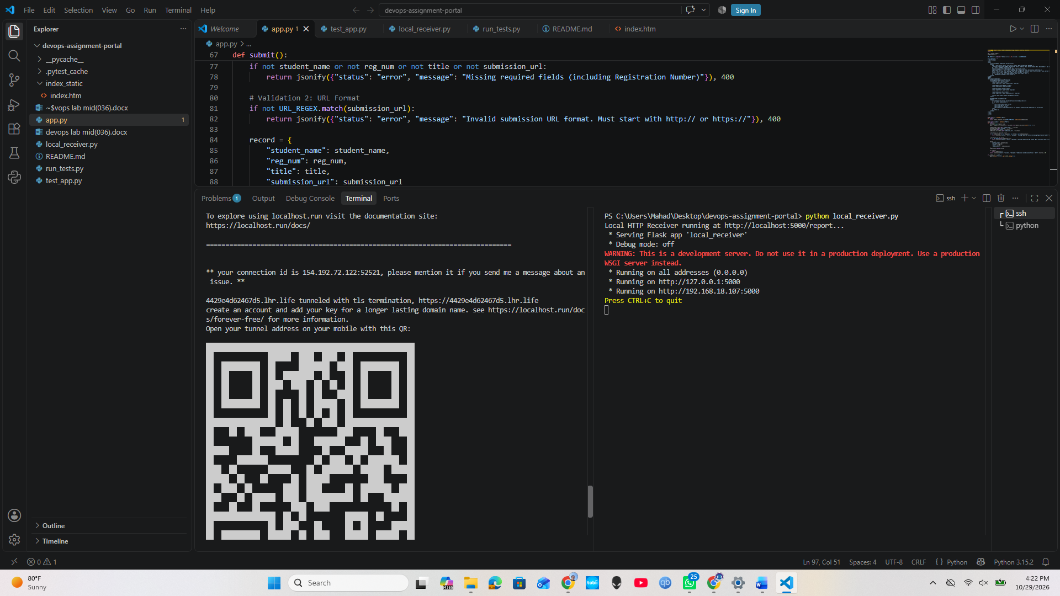

3. GitHub Actions CI/CD Pipeline Setup
The GitHub Actions workflow (.github/workflows/ci.yml) triggers on every push and pull_request to the main branch. It checks out repository code, sets up Python 3.10, installs required packages, executes pytest, and posts a JSON status payload to
Workflow Run Overview:
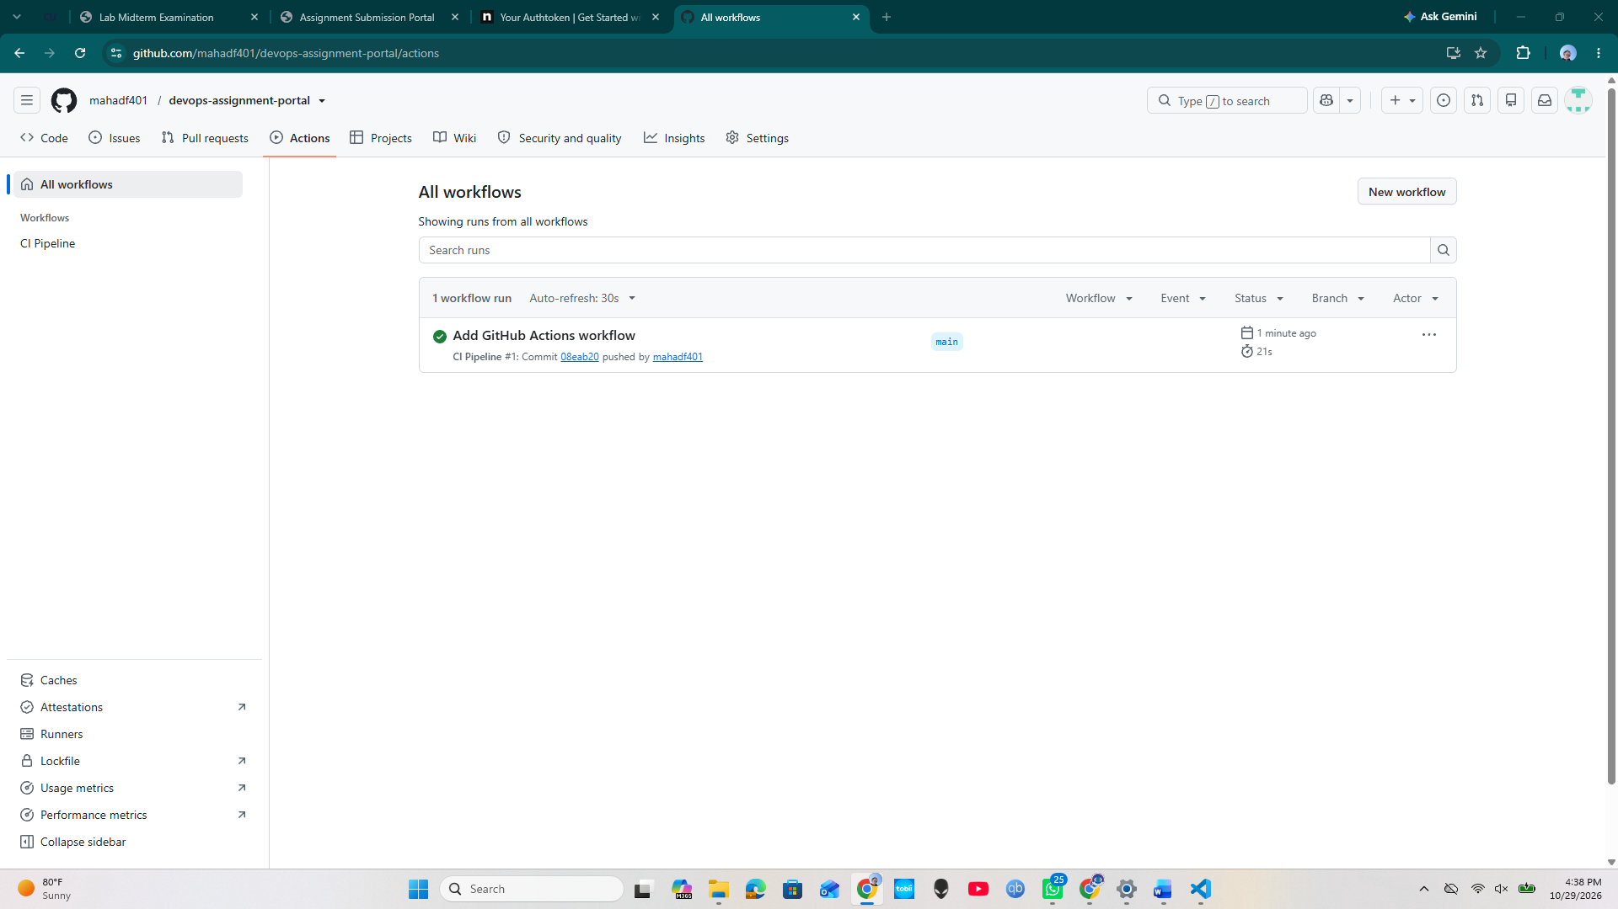
Detailed Pipeline Execution: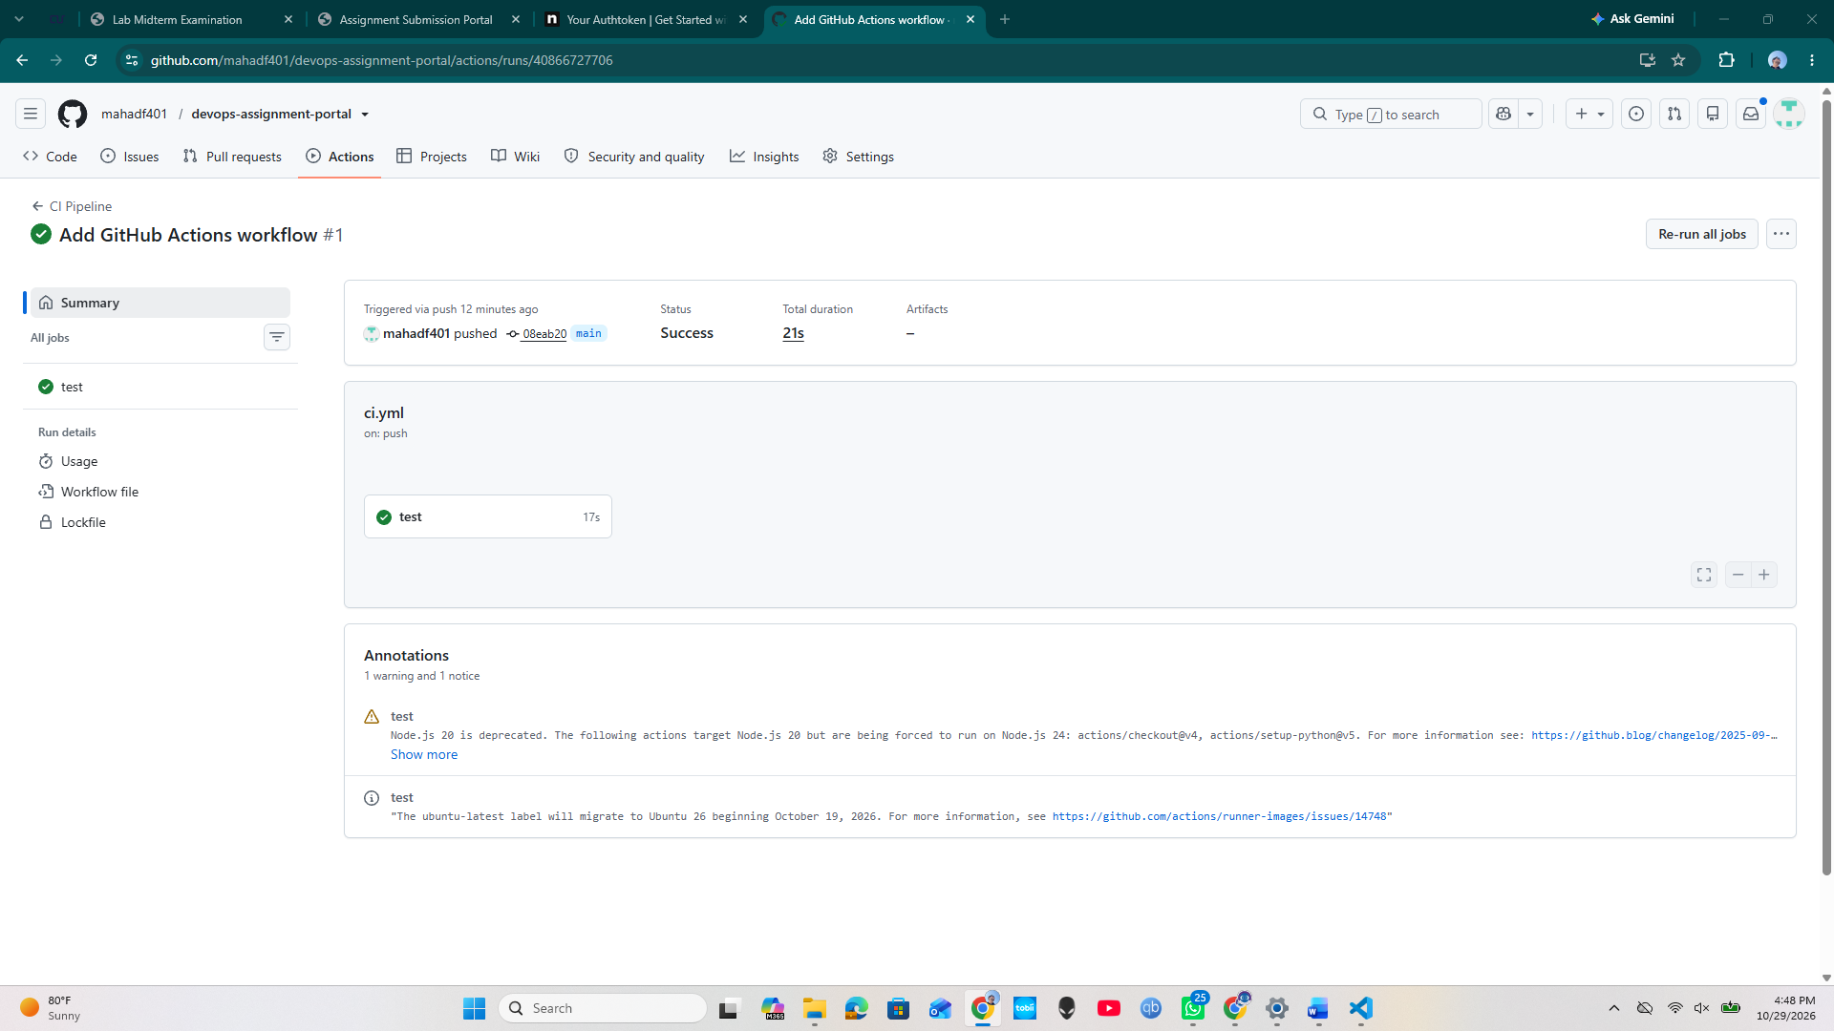

4. Failure Demonstration & Pipeline Recovery
To prove pipeline reliability under error conditions, tests were intentionally broken to verify failure detection, followed by code remediation to validate automated recovery

Pipeline Failure Demonstration:
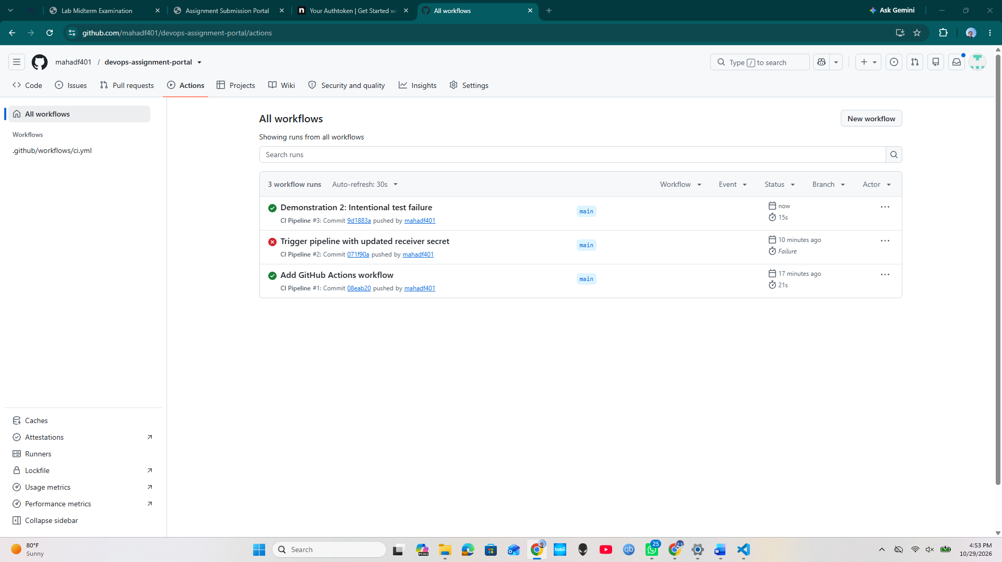
Pipeline Recovery Demonstration:
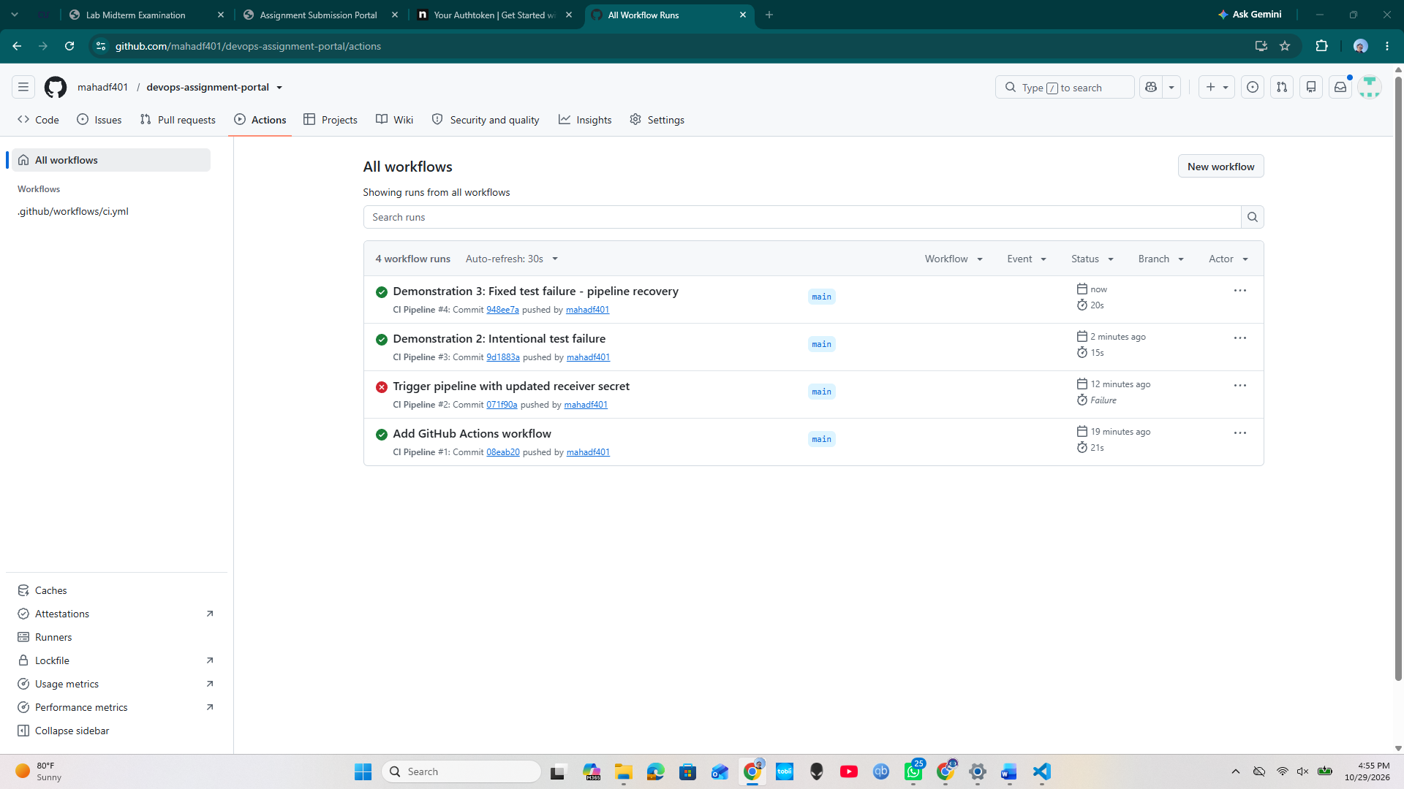
5. Webhook Payload Delivery Verification
Upon completing test steps, the pipeline sends a POST request carrying test status, repository name, commit SHA, and run ID to the webhook receiver
Webhook Receiver Traffic Logs:

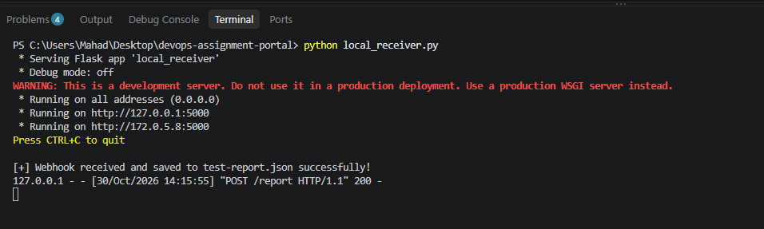

Bonus task 2:
